# BECHAMEL normative choice model inversion

The **Battery of Economic CHoices And Mood/Emotion Links (BECHAMEL)** features 4 types of binary economic discounting decision tasks: delay, risk, physical effort, and mental effort discounting.

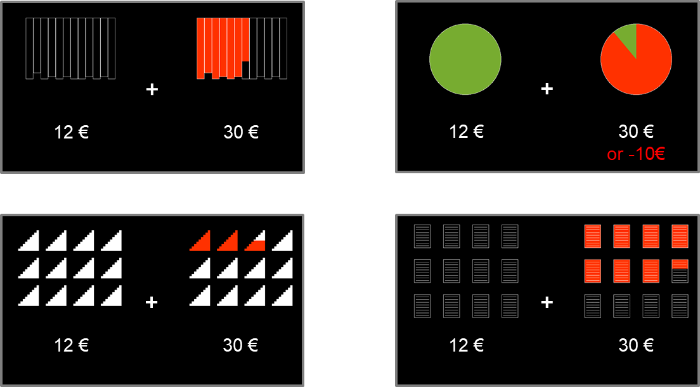

The choice models express the probability of choosing the uncostly option, as a softmax function of the decision value ***DV*** and a weight ***ktrial*** on the trial number ***T***:

$$P\left(uncostly\right) = \frac{1}{1+exp⁡( -β DV- k_{trial} T )}$$

The weight on ***DV*** is the inverse choice temperature $β$. The value of ***DV*** equals the difference between the values of the uncostly option ***V1*** and the costly option ***V2***. The value of the uncostly option is expressed as:

Here, ***R1*** is the reward of the uncostly option, which can vary between 0.10€ and 29.90€. The ***bias*** in favor of the uncostly option can be positive or negative. ***kReward*** is the weight on reward, which returns in the value functions of the costly options.   
These are the expressions for ***V2***, per choice type. Note that the reward ***R2*** for the costly option is fixed to 30€.

Delay discounting

In the delay discounting paradigm, participants either receive a smaller amount of money in cash immediately after the experiment, or they will receive a wire transfer of the larger reward after a certain delay.  
There are two sensible models for delay discounting: a hyperbolic model (model A) and an exponential model (model B). Both are plausible in the sense that their value never goes below zero – which is a prerequisite because there is no opportunity cost to the delay.



$V_{2}= \frac{k_{Reward} R_{2}}{1+ k_{D} D}$

$V_{2}= k_{Reward} R_{2} exp⁡(-k_{D} D)$

Here, the value of the delayed option is a function of the delay ***D*** that can vary from 1 day to 1 year, and that has a discounting factor ***kD***.

Risk discounting

The risk discounting paradigm features a lottery, animated as a spinning wheel-of-fortune, with a possibility to win *or* lose money. Contrary to what a rational agent’s choice model would look like, the value of the risky option here is a function of pure reward, not expected reward. The probability ***P*** of winning the lottery is therefore not multiplied to the reward ***R2***. Moreover, the loss is fixed to -10€, and therefore there is no need to include it in the model, let alone to include a weight on loss.  
The value ***V2*** can either be a linear (model A) function of risk ***(1 – P)***, or there can be a power $γ_{R}$ on risk (model B). The weight on risk is the discounting factor ***kR***.

Physical effort discounting

The physical effort discounting task as depicted above is a choice about climbing a certain amounts of flights of stairs (up to 12) for a reward. Participants are told they are to climb the selected number of flights of stairs after the experiment. Past versions of the physical effort discounting paradigm included biking 15 minutes on a fitness bike at a certain effort level (in Watt, up to 80% of the participant’s calibrated maximum power level).  
In the literature, a common model is the parabolic discounting model (model A). Alternatively, the power $γ_{PE}$ on physical effort ***E*** can be inverted (model B). The weight on physical effort is the discounting factor ***kPE***.

Mental effort discounting

In the mental effort discounting paradigm, participants make a decision about copying lines of text consisting of quasi-Latin non-words. The minimum is 1 line of text, the maximum is 12 pages of text. Each page consists of 25 lines that are numbered. Participants get to view the printed text and copy 5 lines on a lab computer prior to starting the experiment. If a mental effort trial is to be implemented after the experiment, the participants receive a paper copy of the text that they can take home to copy, after which they e-mail the copied text to the experimenters and receive their payment. The text on the paper copy is printed in a font that cannot be scanned and converted by text recognition software.  
There was no a priori model that was preferred for this type of discounting. Therefore, the simplest model is an additive linear function of mental effort (model A). Alternatively, the power $γ_{ME}$ on mental effort ***E*** can be inverted (model B). The weight on mental effort is the discounting factor ***kME***.

Comments about the various parameters

* The weight on reward ***kReward*** is common across all choice types, assuming that an experiment features more than one choice type.
* This is why here, the ***choice bias*** is included in the value function of the uncostly option. It is more commonly added as a term of the choice function outside the decision value, but in that case, the weight on reward ***kReward*** and the inverse choice temperature $β$ could not be dissociated for multiplicative value functions (i.e., the delay discounting models).
* In the flexible power models, i.e. the models with an inverted power on the cost, the values of the discounting factors cannot be compared across participants. Other solutions for comparing would be:
  + Computing the area under the indifference curve
  + Doing a multisession analysis across different experimental conditions such as positive and negative mood, and fixing the power parameter across these conditions. In that way, the conditions’ discounting factors can be compared to each other. In ‘dimensional’ experiments such as one where mood is continuously manipulated, this would require a median split of rated mood, or an a priori session definition.
* The ***choice bias*** and the ***inverse choice temperature*** can either be common parameters across all choice types, or unique parameters for each choice type. It is highly likely that participants have predispositions and levels of noisiness in different choice paradigms, and therefore, by default, these parameters are not taken to be common across choice types.
* All of the following parameters are constrained to be positive using an exponential transform:
  + the weight on reward and on each of the costs (discounting factors)
  + the power parameters
  + the inverse choice temperatures

Therefore, only the ***choice biases*** and the weight on the trial number ***kT*** can be either positive or negative.

How affect is modelled

When affect ***A*** (emotional valence or arousal, or mood) is modelled as a continuum that modulates choices, it can do so as a weight on reward, on cost, on the decision value (i.e., as an inverse choice temperature), and as a choice bias.  
In either case, the parameter is replaced by a version that has a weight on affect ***kA***:

* with ***kCost*** being ***kD***, ***kR***, ***kPE***, and ***kME***
* with ***bias*** being ***biasD***, ***biasR***, ***biasPE***, and ***biasME***
* with ***β*** being ***βD***, ***βR***, ***βPE***, and ***βME***

The weight on affect ***kA*** is common across all choice types and will act as the according parameter (in case affect is modelled as a parameter that is not common across choice types – i.e. any parameter other than ***kReward***).

Overview of the model space

The different ways of modelling the value function of each of the four choice types, makes for a total of 16 different choice models:

|  |  |  |  |  |  |  |
| --- | --- | --- | --- | --- | --- | --- |
| **Value models** | | | | **Choice models** | | |
| **Delay** | **Risk** | **Physical Effort** | **Mental Effort** | **Inv. Choice Temp.** | **Choice Bias** | **Trial number bias** |
| *Hyperbolic* | *Linear* | *Parabolic* | *Linear* | *Per type* | *Per type* | *Yes* |
| *Exponential* | *Flexible power* | *Flexible power* | *Flexible power* |  |  |  |

The models will be inverted for all datasets that have thus far been gathered in the BECHAMEL format. The inversion results will then be compared in a family-wise model comparison, such that per choice type, one value function is the ‘winner’ and ultimately, one set of models will be de normative default for all future BECHAMEL studies.